PAPER ID: 0010

DOI: 10.18462/iir.cryo.2021.0010

NUMERICAL ESTIMATION OF PISTON'S OVERLEAKS IMPACT ON MICROCRYOCOOLER EFFICIENCY.

Shishova NATALIA, Arkharov IVAN, Navasardyan EKATERINA, Zhalyaletdinov RAFAEL

Bauman Moscow State Technical University

Moscow, 105005, Russia, e-mail: nshishova@bmstu.ru

ABSTRACT

Rotary type cryocoolers are widely used to cool sensors of photodetectors of satellite systems and operated in temperature range 90-77K with cooling capacity up to 0.6 kW due to their high thermodynamic efficiency, compactness and the ability to work in any spatial position. Requirements for the performance and durability of such systems are increasing from year to year, so the life time expectation and its prediction play a major role in design process.

A frequent cause of malfunction and failure of such cryocoolers is mechanical wear of the piston-cylinder pair of the discharge cavity. Using of a gas-static suspension or bearing allows increasing the durability by reducing the likelihood of mechanical contact, to reduce vibration and noise, and to provide a "dry" friction mode in the discharge cavity. In the gap, a laminar flow of the working substance (helium) is maintained, which guarantee the maximum bearing capacity of the gas layer at low Reynolds numbers, and provides compensation for the radial oscillations of the piston. The value of the radial gap in the piston-cylinder pair is an optimization parameter, since the size of the working substance overleaks refers to direct losses and affects the Carnot efficiency of the cryocooler, its cooling capacity and COP.

This paper presents the results of numerical simulation of the process of the working substance (helium) overleaks through the 6 μm gap between the piston and the cylinder, and an assessment of influence of these losses on the refrigerating capacity and Carnot efficiency of the cryocooler in the rotor's speed range 1600 ... 3000 rpm and filling pressures 25 … 40 bar.

Obtained results make possible the determination the dependence of the overleaks size and the Reynolds number in the piston-cylinder gap at various combinations of the filling pressure and rotational speed, which, by authors meaning, will allow to solve the problem of optimizing the gap value by minimizing of overleaks while the bearing capacity of the gas-static layer and energy performance of cryocooler keep idem.

**Key words**: cryocooler, durability, Carnot efficiency, design features, lifetime and reliability.

1. **INTRODUCTION**

The main design tasks of rotary-type Stirling cryocoolers with a load 0.6 W in range 90-70 K are increasing of durability and energy efficiency [2,3,8-10]. Different operating requirements should be taken in mind on design stage: ensuring the specified accuracy of maintaining the cryostating temperature; minimizing vibrations that can be transmitted to the cooled device and affect it; limiting of the unit power consumption. Design problems are associated with the non-stationary processes of heat and mass transfer at variable mass of the working substance in case of high speed processes and high specific thermal load, and the influence of various additional factors on the operation of the machine due to its small size [1,6,7]. Acquiring of high energy efficiency with maximum lifetime is a complicated technical problem.

Different failure reasons of the rotary type Stirling cryocoolers are mechanical wear of the piston-cylinder pair of the discharge cavity, decreasing the purity of working gas substance, increasing of motor coil resistance, which follow to rising of unit power consumption [4,5,14,16], its overheating and potential malfunction. For example, the increasing of power consumption can be caused by the stagnation of heat transfer in the regenerator, due to the appearance of metal impurities in the gas working substance as a result of mechanical wear of the friction surfaces or even leaks of it.

Typically, in microscale cryocoolers the gas-static suspension of compression piston is used, that allows increase the durability of the cryocooler by providing the gas lubrication of the piston-cylinder pair and reduce vibration and noise. In the gap of the piston-cylinder pair of the compressor cavity, it is necessary to provide a laminar flow mode of the working substance in order to ensure the maximum coefficient of friction and mechanical carrier capacity of the gas bearing [11,12]. However, overleaks of the working substance through the gap reduce the cooling capacity of the unit as a whole. Based on this claims, the purpose of the present study was conceived and includes simultaneously solving two problems: determining the optimal size of the gap between the piston and the cylinder of the discharge cavity while maintaining the laminar flow mode in it; minimizing energy losses due to leakage of the working substance from the compressor cavity. The gap size is a key parameter of cryocoolers durability and stability because it reflects not only the designed geometry but the mechanical wearing during the whole lifetime and its expectance too. Various factors affect the mechanical wear of the piston-cylinder pair of the discharge cavity: the filling pressure, the rotor speed, the ambient temperature and pressure, the manufacturing technology of components, the assembly quality of the cryocoolers parts, and others [10,15], but all of them finally change the piston-cylinder gap. In our research we try to find the correlations between the leakage of the working substance from the discharge cavity to the suction cavity of the compressor and efficiency of cryocooler for the gap value from 2 to 12 microns at filling pressure from 2.5 to 4.0 MPa and rotor speed from 1600 to 3000 rpm assuming that gas bearing of piston stay stable. The article presents the result of numerical simulation of the mass transfer process in the gap which allowed us to find the Reynolds number in it under the mentioned conditions, the range of mass flow rate changes, and evaluate the effect of working substance losses on the COP of the cryocooler.

1. **MODELING OF THE GAS FLOW THROUGH THE GAP BETWEEN THE PISTON AND THE CYLINDER.**

The main task of optimizing the size of the piston-cylinder gap was splitted on two stages. At the first stage the numerical simulation of the mass transfer (helium) through the gap was done with present independent factors and analysed the influence of these factors on the amount of gas overleaks and Reynolds number. The second stage is the computation of the overleaks influence on the thermodynamic efficiency of the cryocooler and optimizing the gap size.

* 1. COMPUTATION MODEL OF THE MASS FLOW IN THE GAP OF CRYOCOOLER.

Initially the CFD model of a rotary Stirling cryocooler was created by using the ANSYS Workbench software (educational version of the Bauman Moscow State Technical University) and in frame of it the section of compressor cavity described. Design model formed in ANSYS Fluent system and includes the following modules: model geometry (Geometry), model mesh (Mesh), initial and boundary conditions for model calculation (Setup), model calculation (Solution) and display of model results (Results).

For numerical simulation the compressor discharge cavity of a rotary Stirling cryocooler with a cooling capacity of 0.6 W at temperature range 70-90 K was selected, and it have the following geometry:

• compressor piston radius Rc = 7mm;

• piston length Lc = 17 mm;

• compressor piston stroke Sc = 3mm.

The model of the working medium flow through the gap is schematically shown in Figure 1. To simplify CFD modelling, the 3D CAD model is reduced to an axisymmetric simplified 2D model.

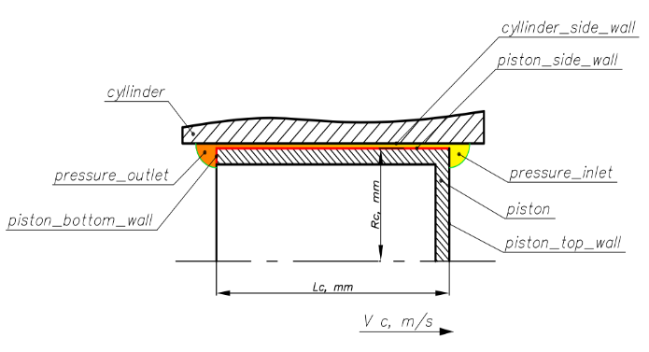

Figure.1 The geometry of the computational section.

The geometry of the model is constrained by the following surface elements (see Figure 1):

• Conditionally adiabatic cylinder wall (cyllinder_side_wall);

• Conditionally adiabatic piston moving with a given speed (piston_side_wall);

• Surface of the piston top (piston_top_wall);

• Surface of the piston bottom (piston_bottom_wall);

• Pressure on the discharge side, indicated by a sector for simplicity of geometry (pressure_inlet);

• Pressure from the low pressure side, similarly represented in the form of the sector (pressure_outlet).

We assume that:

• A two-dimensional 2D model with an axisymmetric arrangement is adopted, and the model elements are cylindrical surfaces with symmetry about the axis;

• The gap is uniform and its dimensions are constant over time;

• The material of the piston and cylinder is selected as aluminium.

In ANSYS Fluent, the geometry of the model was divided into a finite number of elements by computational grid for the numerical solution of differential equations in each element. Computational grid creation was carried out in ANSYS Mesh and is shown on Figure 2.

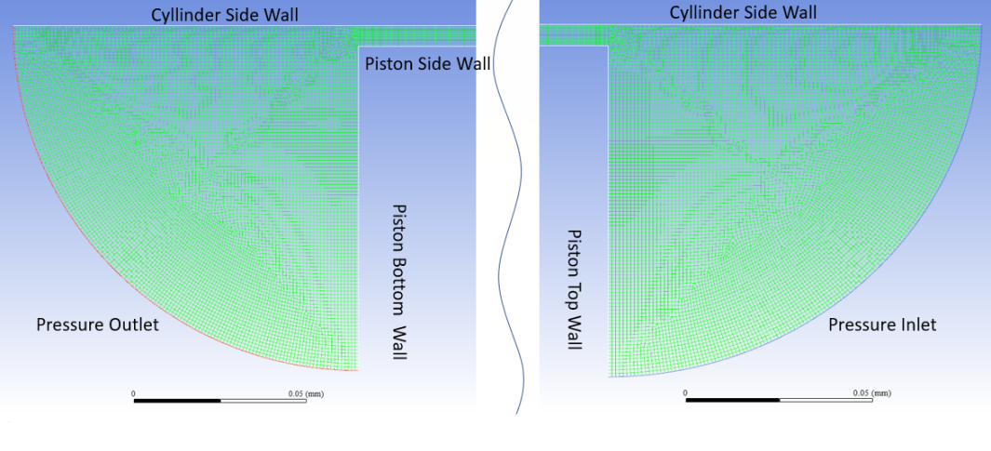

Figure 2. Mesh overlay in ANSYS Mesh on top and bottom model sectors.

The computational grid along the channel length is created by square cells with size 1 μm as square side and the size of the cells reduces at the both sectors of the gap ends to 0.5 μm x 0.5 μm for more accurate calculation.

The boundary conditions for calculating the fluid overleaks are set in the ANSYS Fluent software product as:

• The task is stationary;

• The temperature of the piston and cylinder walls is assumed constant and equal to 300K;

• The cylinder wall is fixed, the piston wall moves according to the harmonious law of the crank rod;

• Computational model of gas flow in the gap - laminar flow regime;

• The choice of the calculation mode is made taking into account the energy equation;

• Material of the piston and cylinder - aluminium with a density of 2719 kg / m3, heat capacity 871 J / (kg * K);

• The working substance is Helium; the calculation is carried out according to the real gas model

of Peng-Robinson, heat capacity 5193 J / (kg * K);

• The pressure irregularity at the inlet and outlet section of the gap is neglected.

Upon the numerical simulation, the stationary and non-stationary problem of the flow regime were solved both. For non-stationary problem the periodic law of pressure change at the top and bottom ends of piston and the speed of the piston moving in time were set. Analysis of the computational error in the calculation results obtained by solving the stationary problem in comparison with non-stationary problem shows that it is not exceed ± 1%. So, taking in mind that calculation of the non-stationary problem takes comparatively more time than the stationary one, due to the large amount of calculations for a combination of various independent factors (filling pressure, gap size, and rotor speed), it was decided to use a stationary mode with acceptable computational error.

* 1. RESULTS OF FLOW DYNAMIC COMPUTATION BY NUMERICAL MODEL.

In numerical experiment, it was assumed that:

• the gap size changed in the range from 2 to 12 μm, with a step of 2 μm;

• crank rod operating frequency range from 1600 to 3000 rpm;

• initial gas filling pressure varied from 2.5 to 4.0 MPa;

• ambient temperature set as 300 K.

The helium flow through the gap was calculated for all range of parameters and over the whole area of the computational grid. Figure 3 is reflecting a flow velocity distribution in gap channel 6 μm size at filling pressure of 3.2 MPa and crank rod speed of 1600 rpm. We can see that the flow regime is stationary laminar.

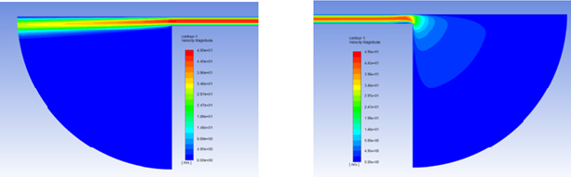Figure 3. Velocity flow distribution in gap channel.

The calculations of gas dynamics in the gap channel were done with setting various combinations of independent factors, and result the dependences of the mass flow rate of overleaks from filling pressure, which shown in Figure 4.

Figure 4. Dependence the mass flow in gap channel from filling pressure at crank rod speed 1600 rpm.

The slope of the curves of helium mass flow in the range of gap sizes from 2 μm to 6 μm shows that it slightly depends from the filling pressure. With increasing of the gap size, the helium mass flow increases tenfold at different values ​​of the filling pressure, the slope of the curves becomes greater, which indicates a noticeable effect on the amount of leaks of the filling pressure and the size of the gap. Thus, with an increase in the gap from 2 μm to 12 μm, the absolute value of the helium mass flow rises up from 1500 to 2500 times, depending on the cryocooler filling pressure.

Also, the provided analysis of the Reynolds number on the gap channel with various sizes and different values ​​of the filling pressure showed that (Figure 5) laminar flow regime kept in all range of parameters. Significant effect the filling pressure on Reynolds number have at gap size more than 10 μm.

Figure 5. Flow regime in gap channel in dependence from filling pressure and gap size (at crank rod speed 1600 rpm.)

The influence of the crank rod speed on flow dynamics and mass flow rate (Figure 6) is quite little in frame of our model, by its assumptions and further not consider gas properties changes along the channel, looks not light to find a tangential velocity of the flow.

Figure 6. The mass flow rate at a gap 6 μm and the Re number at different crank rod speed (filling pressure 4 MPa).

Next we make a try of estimation of influence of helium overleaks in piston gap on the cryocooler thermodynamic

* 1. INFLUENCE OF OVERLEAKS THROUGH THE GAP ON THE Thermodynamic efficiency of cryocooler.

Optimization of the gap between the piston and the cylinder of the discharge cavity includes minimizing of it size while maintaining the gas-static layer and reduce the energy losses of the cryocooler. Under the first step of numerical simulation of the transfer process in the gap channel, the range of its sizes was established - from 2 μm to 6 μm, when the minimum values ​​of helium overleaks and the minimum values ​​of the Reynolds number are observed.

The filling pressure has a decisive effect on the value of dynamic loads in the main structural parts of the Stirling cryocooler during operation. On the one hand, increasing of the filling pressure follows to rising of the working substance in the operation cycle of cryocooler and, accordingly, to growth the cooling capacity without changing of design size of the cryocooler. From the other hand, the high filling pressure leads to an increment of overleaks through the gap between piston and cylinder and enlargement of pressure drops in regenerator, transfer line and operation cycle at all. Therefore, to assess the degree of influence the amount of overleaks on the cooling capacity, Carnot efficiency and COP, we carried out the numerical experiment with various gap size for two filling pressures of 3.0 MPa and 4.0 MPa with equal crank rod speed of 3000 rpm. The values ​​of cooling capacity, Carnot efficiency and COP in gap range from 0 μm to 10 μm, were obtained. These results are shown at Figs. 7 and 8.

Figure 7. Cooling capacity of a rotary-type Stirling cryocooler, depending on the size of the gap between the piston and the cylinder of the discharge cavity at filling pressure of 3.0 MPa and 4.0 MPa and crank rod speed of 3000 rpm.

Figure 8. The COP and Carnot efficiency of a rotary-type Stirling cryocooler, depending on the size of the gap between the piston and the cylinder of the discharge cavity at filling pressure of 3.0 MPa and 4.0 MPa and crank rod speed of 3000 rpm.

The cooling capacity, the Carnot efficiency and COP of the cryocooler lightly change at a gap size up to 6 μm and drops significantly at a gap size above 6 μm. The COP drops from 10,82% to 1,65% and Carnot efficiency change sharply from 30.36% to 4.63% with gap raising from 6 to 10 μm at a filling pressure of 3.0 MPa, similarly the same correlations are observed for a pressure of 4.0 MPa. An analysis of the obtained results shows that the optimal gap is around 6 μm, or even close ​​to 4 μm. In this range, there is no significant loss of cooling capacity and thermodynamic efficiency. The smallest value is quite complicated from fabrication point of view especially for small size cryocooler.

The present numerical model allows one to estimate the values ​​of cooling capacity, COP and Carnot efficiency, in dependence from piston-cylinder gap, but the obtained results are not final. In this case, these values will be the base data for the subsequent multivariate analysis of variance (like ANOVA) to assess the durability of the cryocooler with different influences of independent factors on the operation of the cryocooler.

**3. CONCLUSION**

The numerical study of the working substance flow through the gap between the piston and the cylinder of the discharge cavity under the accepted assumptions allowed us to determine the dependence of the leakage value and the Reynolds number in gap channel at various combinations of filling pressure and rotation speed, and solve the problem of optimizing the gap by minimizing leaks while keeping the load-bearing capacity of the gas-static layer and the energy efficiency of the cryocooler. The optimal range of the gap size at taken into consideration parameters and conditions is 4...6 μm. In this range, there are minimal overleaks and losses of the thermodynamic efficiency.

REFERENCES:

1. Arkharov I.A., et al, 2018. Modeling of hudrodynamics in a porous structure of low temperature regenerator, Journal of Enhanced Heat Transfer, Volume 25, issue 2, pp.169-180 DOI:[10.1615/JEnhHeatTransf.2018027017](http://dx.doi.org/10.1615/JEnhHeatTransf.2018027017)
2. Arkharov I.A., Navasardyan E.S., Shishova N.E., 2020. Multivariate analysis of variance in the reliability estimation of microcoolers. Chemical and petroleum engineering, USA, Vol. 56, issue 7-8, pp. 638–645.
3. Cauquil J.M., Seguineau C., Vasse C., Raynal G., Benschop T. Lifetime validation of high-reliability (>30,000hr) rotary cryocoolers for specific customer profiles. // Proceedings of SPIE Vol. 10626: [Tri-Technology Device Refrigeration (TTDR) III](http://spie.org/Publications/Proceedings/Volume/10626). 2018.
4. Filis A., Haim Z., 2009. Microminiature Stirling cryocooler for compact, lightweight and low power thermal imaging systems. SPIE conference. Web site: https://www.spiedigitallibrary.org/conference-proceedings-of-spie/7298/ 729818/ Microminiature-rotary-Stirling-cryocooler-for-compact-lightweightand-low-power/10.1117/12.818427.short?SSO=1.
5. Kuo D.T., Loc A.S., Lody T.D., and Yuan S.W.K., 1999. Cryocooler Life Estimation and Its Correlation with Experimental Data. Advances of Cryogenic Engineering, vol. 45, pp. 267-273.531-538.
6. Navasardyan E.S., Arkharov I.A., Antonov E.A., 2016. Modeling of processes in microcryogenic gas cooler. Chemical and Petroleum Engineering, USA, V.51(9), pp. 649-655.
7. Navasardyan E.S., Parkin A.N., Kulik V.V., 2016. Numerical modeling procedure for micromachined cryogenic cooler elements using ANSYS fluent software and viscous flow in a small-diameter channel with heat transfer as an Example. Chemical and Petroleum Engineering, USA, V. 52(7), pp. 531-538.
8. Olson J.R., Champagne P., Roth E., 2014. Microcryocooler for tactical and space applications. Adv. Cryog. Eng., V.59, pp. 357–364.
9. Pavlov, I.V., Razgulyaev, S.V., 2020. Calculation of the Basic Reliability Parameters for the Model of a System with Dual Redundancy in Different Subsystems. J. Mach. Manuf. Reliab. 49, pp.829–835. https://doi.org/10.3103/S1052618820100076
10. Ross R.G., 2001. Cryocooler Reliability and Redundancy Considerations for Long-Life Space Missions. Cryocoolers 11, Kluwer Academic, Plenum Publishers, pp. 637-648.
11. Tishchenko I.V., Peshty Yu.V, 2004. Analysis of the characteristics of the gas suspension of the piston in the cylinder of the refrigeration compressor. Herald of the Bauman Moscow State Technical University, Mechanical Engineering, Moscow, pp.166-179.
12. Tishchenko I.V., Peshty Yu.V, 2002. Gas suspension of the piston in the cylinder of the refrigeration compressor. Herald of the Bauman Moscow State Technical University, Mechanical Engineering, Moscow, pp.95-106.
13. Sidnyaev N.I., Butenko1 Iu.I., Bolotova E.E., 2021. The method of aviation systems diagnostics according to the admissible level of non-failure operation probability. [IOP Conference Series: Materials Science and Engineering](https://iopscience.iop.org/journal/1757-899X), [Volume 1061](https://iopscience.iop.org/volume/1757-899X/1061), [Irkutsk, Russia](https://iopscience.iop.org/issue/1757-899X/1061/1).

<https://doi.org/10.1088/1757-899X/1061/1/012037>

1. [Vainshtein](https://www.spiedigitallibrary.org/profile/Igor.Vainshtein-4054921) I., et al., 2018. Overview of RICOR's reliability theoretical analysis, accelerated life demonstration test results and verification by field data. Proc. SPIE 10626, Tri-Technology Device Refrigeration (TTDR) III, 106260G. <https://doi.org/10.1117/12.2309549>
2. Van de Groep W. et al, 2012. Update on MTTF figures for linear and rotary coolers of Thales Cryogenics. Proceedings of the SPIE, vol. 8353. DOI: [10.1117/12.918245](https://ui.adsabs.harvard.edu/link_gateway/2012SPIE.8353E..1SV/doi:10.1117/12.918245)
3. Xinguang Liu; Yinong Wu; Guohua Lu, et al., 2011. Failure analysis of the space Stirling cryocoolers. The Proceedings of 2011 9th International Conference on Reliability, Maintainability and Safety. DOI: 10.1109 / ICRMS.2011.5979409